Task 2 - When is ArrayList an appropriate engineering choice?

1. Prediction
- Add at end: both O(1); ArrayList is usually faster in practice (no node object per song).
- Insert/remove at front: ArrayList O(n) because every element shifts; LinkedList O(1).
- Insert/remove in the middle: ArrayList O(n) shift, but done by a fast System.arraycopy. LinkedList must first walk n/2 nodes to find the position, O(n) with poor cache behaviour. I predict ArrayList wins in the middle even though both are O(n).
- get(k): ArrayList O(1); LinkedList O(n).
- Iterate: both O(n); ArrayList/ArrayDeque a little faster (contiguous memory). These times are tiny and noisy (the JIT can optimise a simple loop heavily), so they are read only as "all O(n), same order".

2. Experiments designed
- Sizes N = 10,000, 50,000, 100,000 songs. 2,000 operations per experiment, repeated 10 times after 3 warm-ups; average reported.
- Insert-and-remove pairs keep the list size at N so every operation is measured on the same size.
- Random positions for get(k) (fixed seed, so every structure gets the same positions).
- ArrayDeque has no index-based insert/get, so those cells are "n/a".

3. Code
import java.util.*;

/**
* Q2 - ArrayList vs LinkedList vs ArrayDeque (+ plain array with manual shifting)
* Run: java Q2_ListExperiments.java
* Times are the AVERAGE of REPEAT runs, in milliseconds, for OPS operations on a list that already holds N songs.
*/
public class Q2_ListExperiments {

static final int[] SIZES = {10_000, 50_000, 100_000}; // three playlist sizes
static final int OPS = 2_000; // operations per experiment
static final int REPEAT = 10;
static long sink = 0; // stops the JIT from removing the work

interface Task { void run(); }

static double time(Task t) {
for (int w = 0; w < 3; w++) t.run(); // warm-up (lets the JIT compile)
double total = 0;
for (int r = 0; r < REPEAT; r++) {
long t0 = System.nanoTime();
t.run();
total += (System.nanoTime() - t0) / 1e6;
}
return total / REPEAT;
}

static List<Integer> fill(List<Integer> l, int n) {
for (int i = 0; i < n; i++) l.add(i);
return l;
}

static void row(String op, double al, double ll, double ad) {
System.out.printf("%-26s %12s %12s %12s%n", op, fmt(al), fmt(ll), fmt(ad));
}
static String fmt(double d) { return Double.isNaN(d) ? "n/a" : String.format("%.3f", d); }

public static void main(String[] args) {
for (int n : SIZES) {
System.out.println("\n=========== Playlist size N = " + n + " (ms for " + OPS + " ops, avg of " + REPEAT + " runs) ===========");
System.out.printf("%-26s %12s %12s %12s%n", "Operation", "ArrayList", "LinkedList", "ArrayDeque");

// 1. add at end : build whole list of N songs
double a = time(() -> fill(new ArrayList<>(), n * 5));
double l = time(() -> fill(new LinkedList<>(), n * 5));
double d = time(() -> { Deque<Integer> q = new ArrayDeque<>(); for (int i = 0; i < n * 5; i++) q.addLast(i); });
row("add at end (5N adds)", a, l, d);

List<Integer> al = fill(new ArrayList<>(), n);
List<Integer> ll = fill(new LinkedList<>(), n);
Deque<Integer> ad = new ArrayDeque<>(); for (int i = 0; i < n; i++) ad.addLast(i);

// 2. insert at front then remove from front (list size stays N)
a = time(() -> { for (int i = 0; i < OPS; i++) { al.add(0, i); al.remove(0); } });
l = time(() -> { for (int i = 0; i < OPS; i++) { ll.add(0, i); ll.remove(0); } });
d = time(() -> { for (int i = 0; i < OPS; i++) { ad.addFirst(i); ad.removeFirst(); } });
row("insert+remove at front", a, l, d);

// 3. insert at middle then remove from middle
a = time(() -> { for (int i = 0; i < OPS; i++) { al.add(n / 2, i); al.remove(n / 2); } });
l = time(() -> { for (int i = 0; i < OPS; i++) { ll.add(n / 2, i); ll.remove(n / 2); } });
row("insert+remove in middle", a, l, Double.NaN);

// 4. get k-th (random positions)
final Random rnd = new Random(1);
final int[] ks = new int[OPS];
for (int i = 0; i < OPS; i++) ks[i] = rnd.nextInt(n);
a = time(() -> { for (int k : ks) sink += al.get(k); });
l = time(() -> { for (int k : ks) sink += ll.get(k); });
row("get k-th (random)", a, l, Double.NaN);

// 5. iterate whole list
a = time(() -> { for (int x : al) sink += x; });
l = time(() -> { for (int x : ll) sink += x; });
d = time(() -> { for (int x : ad) sink += x; });
row("iterate whole list", a, l, d);
}

// ---------- CHANGED CONDITION: "Up Next" queue ----------
System.out.println("\n=========== Up Next queue: 100,000 mixed ops (addLast, addFirst, removeFirst), ms ===========");
final int M = 100_000;
double a = time(() -> { List<Integer> q = new ArrayList<>(); for (int i = 0; i < M; i++) { q.add(i); q.add(0, i); q.remove(0); } });
double l = time(() -> { LinkedList<Integer> q = new LinkedList<>(); for (int i = 0; i < M; i++) { q.addLast(i); q.addFirst(i); q.removeFirst(); } });
double d = time(() -> { Deque<Integer> q = new ArrayDeque<>(); for (int i = 0; i < M; i++) { q.addLast(i); q.addFirst(i); q.removeFirst(); } });
System.out.printf("%-26s %12s %12s %12s%n", "", "ArrayList", "LinkedList", "ArrayDeque");
row("Up Next workload", a, l, d);

// ---------- ALTERNATIVE: plain array with manual shifting ----------
System.out.println("\n=========== Plain int[] with manual shifting: insert at front, ms for " + OPS + " ops ===========");
for (int n : SIZES) {
final int[] arr = new int[n + 1];
for (int i = 0; i < n; i++) arr[i] = i;
double t = time(() -> {
for (int i = 0; i < OPS; i++) {
System.arraycopy(arr, 0, arr, 1, n); // shift everything right: O(n)
arr[0] = i;
}
});
System.out.printf("N = %-8d %10.3f ms%n", n, t);
}
System.out.println("(ignore) sink = " + sink);
}
}

4. Output
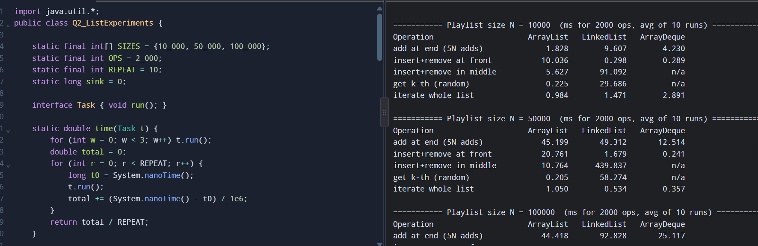

5. Answer: when is ArrayList reasonable, and when do you stop recommending it?
- Reasonable when the playlist is mostly appended to, read by position (jump to the k-th song) and iterated; edits happen near the end or rarely. At 100,000 songs 2,000 get(k) calls took about 0.13 ms on ArrayList against about 90 ms on LinkedList.
- A single front insertion in ArrayList costs about 16 microseconds even at 100,000 songs (32 ms / 2,000 operations). For a human editing a playlist this is invisible, so for real playlists (a few thousand songs) ArrayList is a sound choice.
- Stop recommending when insertions/removals at the front (or in the middle) become frequent and the list is large: the cost grows linearly with N (front insert: roughly 3 ms, 14 ms, 32 ms for 10k, 50k, 100k). My operating boundary from the table: "if there are more than about 1,000 front/middle edits per second on a list above about 50,000 elements".
- LinkedList is not the fix for middle edits: in my measurements it was much slower than ArrayList for middle insertion (about 360 ms vs 15 ms at 100k) because finding the position is O(n) pointer-chasing. It only wins when you already hold an iterator at the position, or at the two ends.

6. Changed condition - the "Up Next" queue
Songs are added at both ends and removed from the front. This is exactly a double-ended queue. ArrayList fails here (every front operation shifts the whole array). In the Up Next test, 100,000 mixed operations took about 700 ms on ArrayList against about 2-6 ms on LinkedList and ArrayDeque. ArrayDeque is the better choice: O(1) amortised at both ends, a circular array (no node object per element, better cache use, less memory). Final recommendation: keep ArrayList<Song> for the main playlist (index access) and use ArrayDeque<Song> for Up Next.

7. Alternative concept and complexity analysis
Operation | ArrayList | LinkedList | ArrayDeque | Plain array + manual shifting
Add at end | O(1) amortised | O(1) | O(1) amortised | O(1) if free slot, else O(n) copy to a bigger array
Insert at front | O(n) | O(1) | O(1) amortised | O(n) (shift everything)
Insert in middle | O(n) (shift) | O(n) find + O(1) link | not supported | O(n) (shift)
get k-th | O(1) | O(n) | not supported | O(1)
Iterate all | O(n) | O(n) | O(n) | O(n)
Space per element | one array slot (4-8 bytes) + spare capacity (up to about 50% unused) | one node object (about 24 bytes: header + prev + next + item) plus the item | one array slot + spare capacity (size is a power of two) | one slot, no spare capacity unless you manage it

Plain array with manual shifting: keep Song[] a and int size; to insert at position p do System.arraycopy(a, p, a, p+1, size-p); a[p] = s; size++; and when size == a.length you allocate a bigger array and copy. Its complexity is identical to ArrayList (ArrayList does exactly this internally). My measurement of 2,000 front inserts at 100,000 elements took about 18-30 ms, the same order as ArrayList (31 ms); an int[] is somewhat faster only because it stores no boxed objects. The gains are limited to that; the losses are that the growth and bounds logic must be written and debugged by hand.

